Community Council Report
Llandow Ward
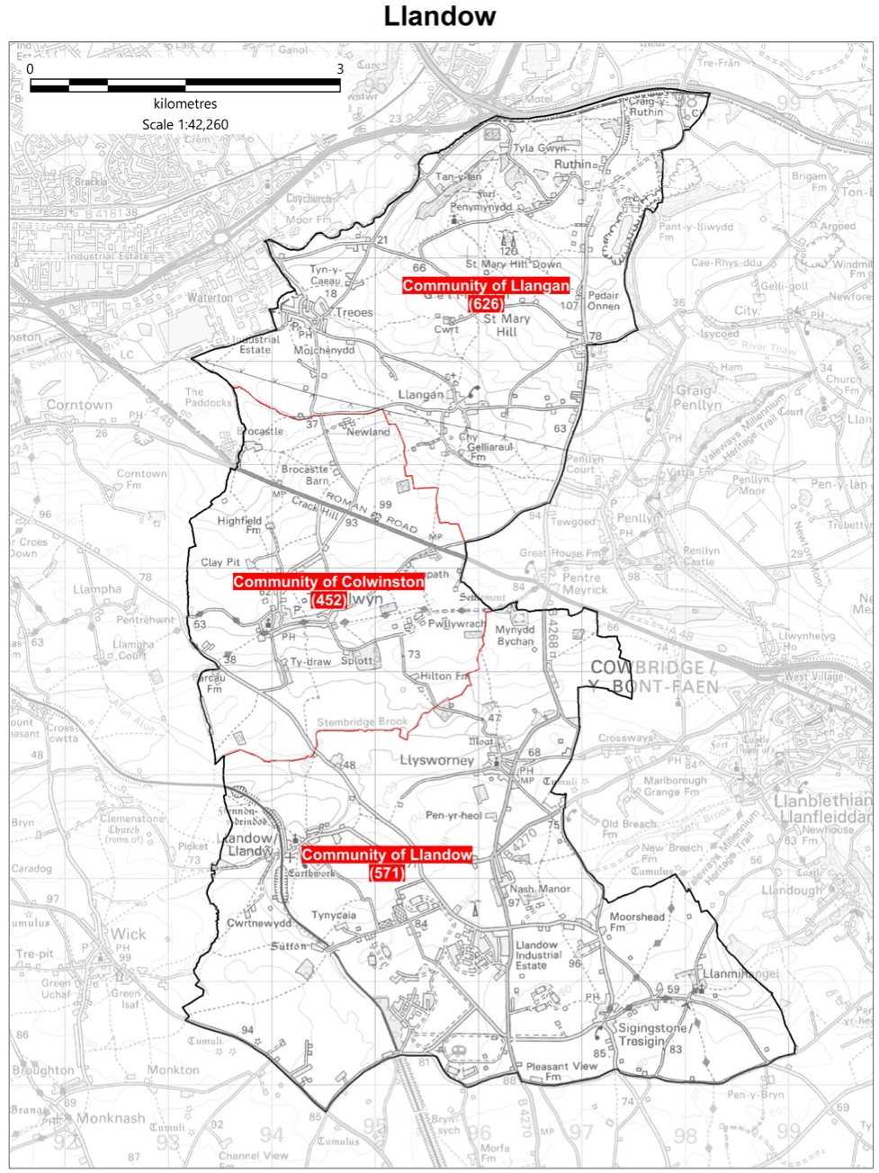
Cllr. Christine Cave email: cacave@valeofglamorgan.gov.uk
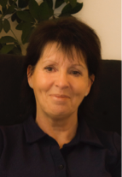
Date: June 2026 Report to the Community Councils (CC) in the Llandow Ward: Colwinston; Llandow, Llysworney, Sigingstone, Sutton and Llangan/Treoes and St Mary Hill.

Vale of Glamorgan Full Council meeting to April 2027

13th July, 28th September, 7th December, 8th March, 26th April

Members of the Cabinet
Councillor L. Burnett (Executive Leader and Cabinet Member for Performance and Resources)
Councillor B.E. Brooks (Deputy Leader and Cabinet Member for Sustainable Places)
Councillor R.M. Birch (Cabinet Member for Education, Arts and the Welsh Language)
Councillor G. John (Cabinet Member for Leisure, Sport and Well-being)
Councillor S.D. Perkes (Cabinet Member for Public Sector Housing and Tenant Engagement)
Councillor S. Sivagnanam (Cabinet Member for Community Engagement, Equalities and Regulatory Services)
Councillor E. Williams (Cabinet Member for Social Care and Health)
Councillor M.R. Wilson (Cabinet Member for Neighbourhood and Building Services)

Cabinet meetings held in May 2026 - 28TH MAY, 2026 AT 2.00 PM
Type/Venue: HYBRID MEETING [EASYCONF / CHAMBER]
Agenda - PART I

1. Apologies for absence.
2. To receive declarations of interest and the nature of such interests under the Council's Code of Conduct.
(Note: Members seeking advice on this item are asked to contact the Monitoring Officer or Democratic Services at least 48 hours before the meeting.)
3. Minutes of the Meeting held on 30th April, 2026.
Reference –
4. Audit Wales: Vale of Glamorgan Council Audit Plan 2026 – Governance and Audit Committee: 13th April, 2026.
Reports of the Executive Leader and Cabinet Member for Performance and Resource –
5. Appointments to Outside Bodies / Joint Committees.
6. Vale of Glamorgan Council Annual Statement 2026/2027.
7. Q4 Sickness Absence Report 2025/2026.
8. Barry Making Waves Levelling Up Fund Update Report.
9. Pride in Place Programme – Barry.

Reports of the Deputy Leader and Cabinet Member for Sustainable Places –
10. Active Travel Network Map Update 2026.
11. Local Area Energy Plan.
Report of the Cabinet Member for Neighbourhood and Building Services –
12. Objection Report: Dryden Road, Penarth – Proposed School Street Traffic Regulation Order.
Report of the Cabinet Member for Leisure, Sport and Well-being –
13. Belle Vue Pavilion – Operating Model and Governance Arrangements.
14. Any items which the Chair has decided are urgent (Part I).

Cabinet meetings to be held in June 2026 – June 11th and 25th.

Current consultations

Current consultations

Active Adults Survey
What activities do you currently take part in? Are there any exercise or sport opportunities you’...
View Project

Moving Traffic Enforcement
We want to hear your views about our plans to apply for powers to enforce moving traffic offences...
View Project

Placemaking
Welcome to our Placemaking hub, a platform for you to share your views on how to improve our town...
View Project

Barry - Plan for Neighbourhoods
If you would like to get involved in shaping Barry’s future, please register your interest here.
View Project

Local Matters

- Colwinston/Llandow/Llangan – Matters raised in relation to training requirements and information following the Boundary Commission review of Town and Community Councils – The Commission has now published its Final Recommendations Report for the Electoral Arrangements in the Vale of Glamorgan. https://www.dbcc.gov.wales/reviews/01-26/vale-of-glamorgan-final-recommendations
- Colwinston/Llandow/Llangan – request made to the director of highways to make urgent repairs to the access road to the Llandow recycling centre – ongoing.
- Colwinston/Llangan/Llandow – Planning matter Lidl’s Llanmaes – Welsh Government have ‘called in’ and intend to hold a public enquiry – ongoing
- Colwinston - Adoption of the vines– (easements signed) waiting confirmation from Persimmon Homes - ongoing
- Colwinston – RLDP – information provided to members – ongoing
- Colwinston – RLDP proposed affordable housing – request made to planning department regarding changes to the settlement boundary response as follows: All of the proposed allocations (Vale wide), if adopted, would result in the change of settlement boundaries to incorporate those sites- as logically they would then be included. The recent consultation that ended on 11th March included these proposals, albeit if the RLDP were adopted, there would still need to be a Planning application for any development of that site. The link below takes you to the Settlement Boundary document, that formed part of the consultation, which shows all proposed changes to settlement boundaries, including but limited to proposed allocations. BP46 Settlement Boundary Review compressed.pdf
- Colwinston – Dog bins request for more frequent cleaning and the possibility of increased number of bins – ongoing
- Colwinston – request for food waste bags for the Sycamore Tree – delivery expected first week of June.
- Llandow – Sigingstone – Unauthorised signage – information sent to enforcement team – ongoing
- Llandow – Sigingstone – planning reference 2021/00209/FUL - Land to the South West of Sigingstone - residential development of 10 dwellings and associated infrastructure works‘call in’ request made to Welsh Government – ongoing
- Llandow – Field water run off – meeting held by subgroup in November and agreed a full meeting will be held the 21st September 2026 – invitations sent out - ongoing
- Llandow – hedgerow removal and new entrance without planning permission raised with VoG planning department and enforcement team – planning application received for ‘Will’s Yard see https://www.valeofglamorgan.gov.uk/Documents/_Committee%20Reports/Cabinet/2026/26-03-26/Ref-from-GA-Corporate-Complaints-Support-Service-Improvement.pdf consultation stage - ongoing
- Llandow – Poor state of the play area in Llandow – meeting held with parks team in June – and again in August with the Play team. Play team attended Llandow CC meeting in December – no response heard since - ongoing
- Llandow – Sigingstone – clearing of the pond – meeting discussed several issues that are now connected with a wider area of possible ‘asset transfer’ proposals. Information provided regarding completion of the stage two – ongoing
- Llangan/Llandow – Speeding traffic and volume of traffic on the rural roads raised again with VoG - this is an ongoing issue – suggested that this matter be raised with Community Liasion Committee
- Llangan – RLDP concerns raised with VoG planning department – ongoing
- Llangan - Unresolved flooding issue in Treoes – reported – ongoing
- Llangan – Planning enforcement issue raised – stop notice Ffern Coch House, ongoing
- Llangan Ruthin Commoners Association – meeting arranged to discuss ongoing matters – planning, bench removal, fly tipping and road access.

Scheduled Meetings for June 2026 - All Meetings commence at 6.00 p.m. and will be held virtually unless otherwise stated

Council |  | Early Retirement/Redundancy (4.00 p.m.) | 25th June
Annual Meeting |  | Licensing - Public Protection (10.00 a.m.) | 16th June
Cabinet (2.00 p.m.) | 11th June  25th June | Licensing - Statutory
Scrutiny (Resources) | 10th June | Licensing Sub
Scrutiny (Start Well) |  | Planning (4.00 p.m.) | 18t^{h} June
Scrutiny (Live Well) |  | Public Rights of Way
Scrutiny (Place) | 2nd June | Senior Management Appointment
Appeals |  | Standards | 4th June
Governance and Audit | 22nd June | Trust
Community Liaison |  | Vale of Glamorgan Local Access Forum
Democratic Services (4.00 p.m.) | 29th June | Voluntary Sector Joint Liaison
Investigating |  | Welsh Church Act Estate (4.00 p.m.) | 8th June
 |  | Shared Regulatory Services Joint Committee  (10.00 a.m.) | 24th June

